PLO2-PI2.1 (2) CPU scheduling is the basis of ___________
Select one:
a. All of the above.
b. Larger memory sized systems.
c. Multiprogramming operating systems.
d. Multiprocessor systems.
Clear my choice

Which of the following is not correct regarding FCFS?
Select one:
a. FCFS is easy to understand and implement.
b. Its implementation is based on FIFO queue.
c. Average wait time is high.
d. FCFS scheduling algorithm is preemptive.

PLO2-PI2.1 (2) ___________scheduling is a __________algorithm and one of the most common scheduling algorithms in batch systems.

Select one:
a. Priority/ nonpreemptive
b. Priority/ preemptive
c. Shortest Remaining Time/ nonpreemptive
d. Round Robin/ nonpreemptive

PLO2-PI2.1 (2) Describe disadvantage of the One to One Model ?

Select one:
a. increased concurrency provided by this model
b. creating a user thread requires creating the corresponding kernel thread
c. creating so many threads at once can crash the system
d. decreased concurrency provided by this model

PLO2-PI2.1 (2) which of the following is not contained by a Process Control Block (PCB)?
Select one:
a. Data
b. Bootstrap program
c. Stack
d. Code

Select one:
a. It may lead to the "convoy effect" where shorter processes are stuck behind longer ones.
b. It is a non-preemptive scheduling algorithm.
c. FCFS scheduling algorithm is preemptive.
d. It follows the principle of first come, first served.

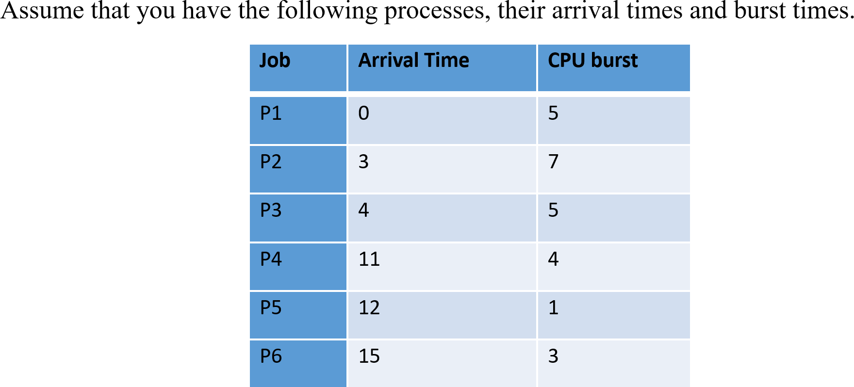
For FCFS scheduling algorithms, determine the waiting times for the average waiting times.
Select one:
a. 9.6
b. 8,7
c. 5,3
d. 10

For Round Robin (Time Quantum = 5) scheduling algorithms, determine the waiting times for P5
Select one:
a. 8
b. 10
c. 7
d. 15

- PLO2-PI2.1 (2) Identify a system is in the safe state if:
I. The system can allocate resources to each process in some order and still avoid a deadlock.
II. There exists a safe sequence.
a. II
b. I
c. both I and II.
d. Neither I nor II.

- Choose the best method that is a visual (mathematical) way to determine the deadlock occurrence
a. resource allocation graph
b. none of the mentioned
c. inversion graph
d. starvation graph
- PLO2-PI2.2 (3) Compute of the Need matrix, using the banker’s algorithm.
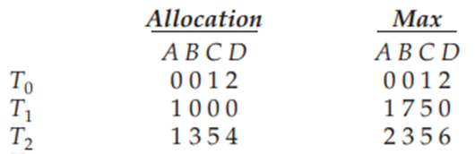
a. The values of Need for processes P₀ through P₄ (0, 1, 0, 0), (0, 7, 5, 0), (1, 4, 0, 2)
b. The values of Need for processes P₀ through P₄ (0, 0, 0, 1), (0, 7, 5, 0), (1, 2, 0, 2)
c. The values of Need for processes P₀ through P₄ (0, 0, 0, 0), (0, 7, 5, 0), (1, 0, 0, 2)
d. The values of Need for processes P₀ through P₄ (0, 0, 2, 0), (0, 7, 5, 0), (1, 0, 1, 2)

- PLO2-PI2.2 (3) Choose the safe state in a system, using the banker’s algorithm.
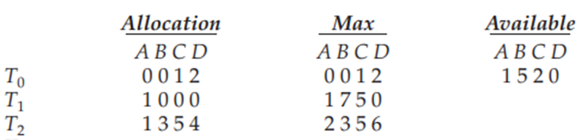
a. P1 -> P2 -> P0
b. P1 -> P0 -> P2
c. P2 -> P0 -> P1
d. P0 -> P2 -> P1

- PLO2-PI2.2 (3) Choose the safe state in a system, using the banker’s algorithm.
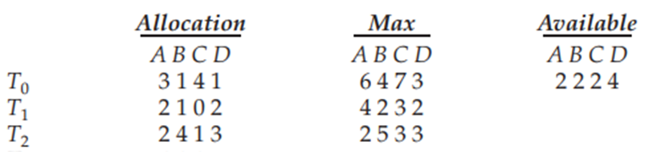
a. P2 -> P1 -> P0
b. P1 -> P0 -> P2
c. P2 -> P0 -> P1
d. P1 -> P2 -> P0

- A process is said to be in the ___ state if it was waiting for an event that will never occur.
a. Terminate
b. Ready
c. Deadlock
d. Blocked

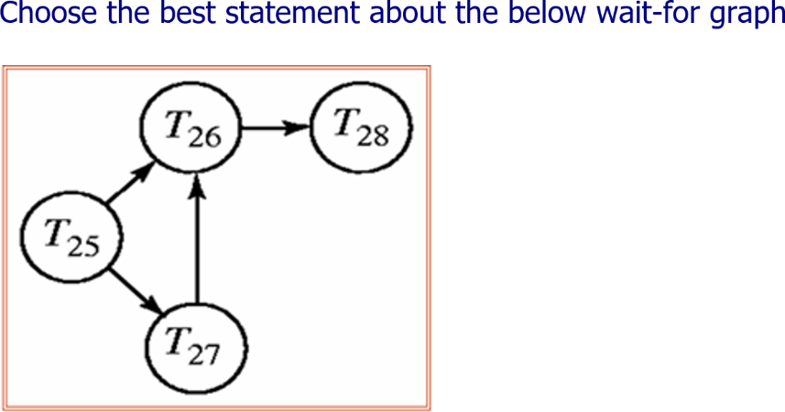
a. This is a no-loop graph
b. All are true
c. The graph is not correct
d. This absolutes having a deadlock

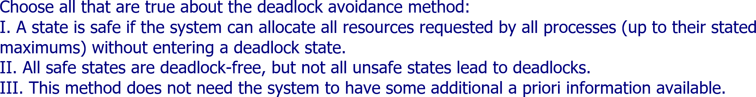
Select one:
a. I, II
b. I, II, III
c. I, III
d. II, III

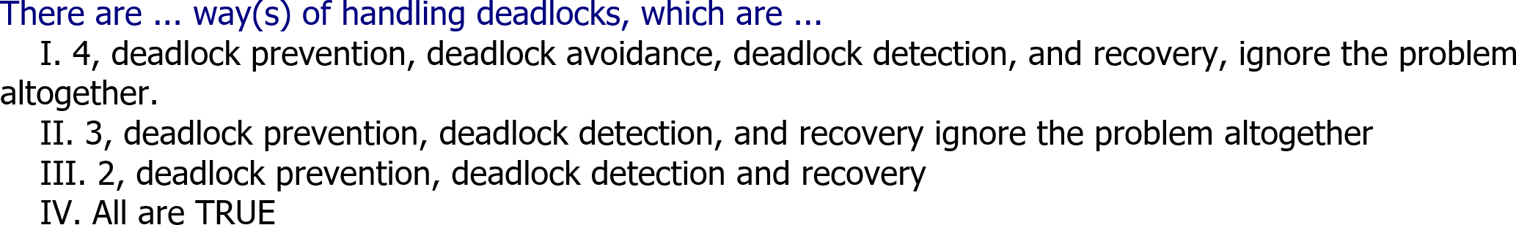
Select one:
a. I
b. III
c. IV
d. II

- PLO2-PI2.2 (3) Compute of the Need matrix, using the banker’s algorithm.
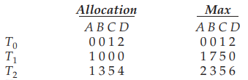
a. The values of Need for processes P₀ through P₄ (0, 1, 0, 0), (0, 7, 5, 0), (1, 4, 0, 2)
b. The values of Need for processes P₀ through P₄ (0, 0, 0, 1), (0, 7, 5, 0), (1, 2, 0, 2)
c. The values of Need for processes P₀ through P₄ (0, 0, 0, 0), (0, 7, 5, 0), (1, 0, 0, 2)
d. The values of Need for processes P₀ through P₄ (0, 0, 2, 0), (0, 7, 5, 0), (1, 0, 1, 2)

- The page table contains ____________
A. page offset
B. none of the mentioned
C. base address of each page in physical memory
D. page size

- A system with 5 processes P0 through P4 and three resource types A, B, C have A with 10 instances, B with 5 instances, and C with 7 instances. At time t0, the following snapshot has been taken:
Process
P0
P1
P2
P3
P4

Allocation (process-wise : P0 through P4 top TO bottom)
A B C
0 1 0
2 0 0
3 0 2
2 1 1
0 0 2

MAX (process-wise: P0 through P4 top TO bottom)
A B C
7 5 3
3 2 2
9 0 2
2 2 2
4 3 3

Available
A B C
3 3 2
The sequence <P1, P2, P3, P4,P0> leads the system to ____________
A. a safe state
B. an unsafe state
C. a protected state
D. a deadlock

- To avoid deadlock ____________
A. there must be a fixed number of resources to allocate
B. resource allocation must be done only once
C. all deadlocked processes must be aborted
D. inversion technique can be used

- PLO2-PI2.1 (2) Choose the best method that is a visual (mathematical) way to determine the deadlock occurrence
a. inversion graph
b. none of the mentioned
c. resource allocation graph
d. starvation graph

- PLO2-PI2.2 (3) Apply Dynamic Storage-Allocation using first-fit method, what is the remaining memory?
Given five memory partitions of 100 KB, 600 KB, 200 KB, 300 KB, and 500 KB (in order), place processes of 212 KB, 417 KB, 112 KB, and 426 KB (in order)?
a. All are right.
b. 100, 276,200,300,83
c. 100,388,200,300,388
d. All are wrong.

- PLO2-PI2.1 (2) Choose the best answer about the Paging
I. Paging allows modular programming.
II. Paging solves the memory fragmentation problem
III. Paging avoids deadlock.
a. I
b. III
c. Both I and II
d. II

- PLO2-PI2.1 (2) Describe of the following is the deadlock avoidance algorithm?
a. round-robin algorithm
b. elevator algorithm
c. karn's algorithm
d. banker's algorithm

